UDS PED Safety Toolkit Info
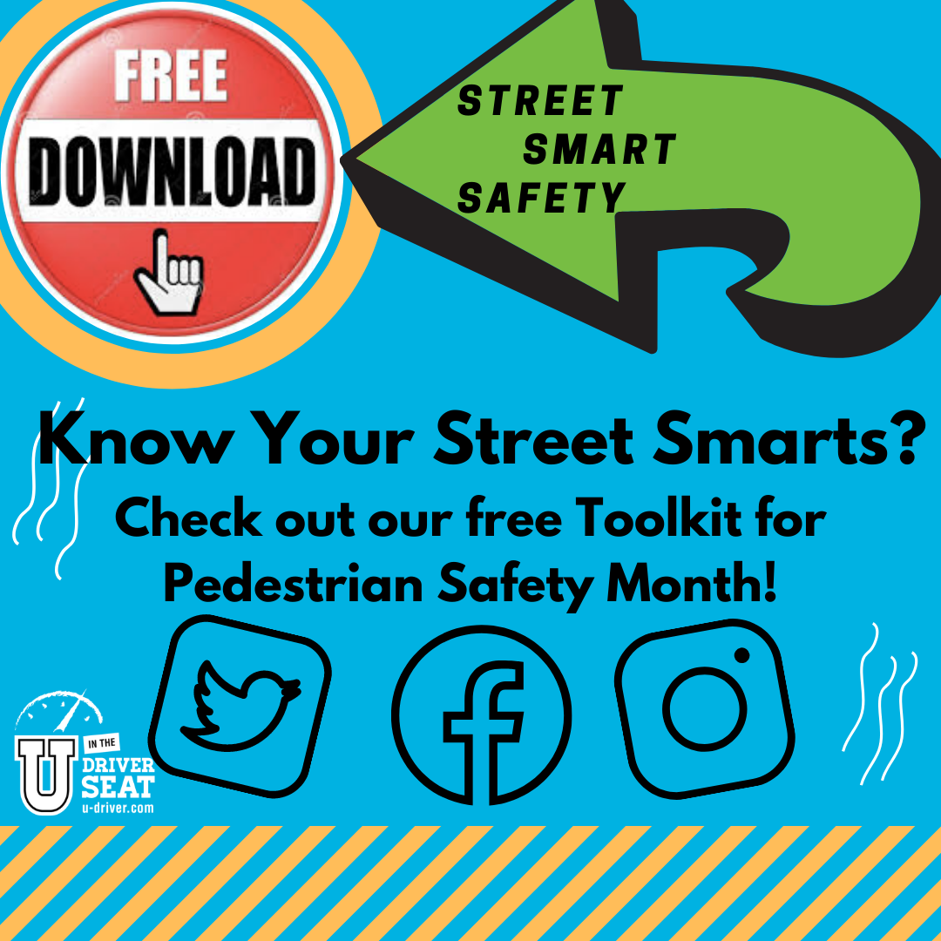
U in the Driver Seat provides the science, resources and support to effectively engage and educate your peers on a variety of traffic safety topics. This social media toolkit is to assist you in talking to your peers about pedestrian safety and Texas laws. Our downloadable graphics are square sized for use on various social media channels to display as an album on Instagram or Facebook. We encourage you to make the post your own, but here are some ways to really make it great!
- Tag @UDriverSeat on social media to receive All-Star points
- Add your organization logo to the beginning and ending graphic
- Share the posts to your Instagram or Facebook story
- Invite your Regional Rep to do a Instagram Live interview on the topic
- Host an Ask Me Anything Instagram Story after posting the graphics
- Use the graphics to build out a blog post for your website

Sample text for photos:
- Do your part to be seen at night! Wear bright or reflective clothing to make yourself more visible to drivers! #PEDSafety #PedestrianSafetyMonth
- Pedestrians do not always have the right of way! Recognize when it is safe for you to cross a street and always look both ways! #PEDSafety #PedestrianSafetyMonth
- Always look for a crosswalk before crossing the street! If one is available, wait for the right moment to cross to stay safe! #PEDSafety #PedestrianSafetyMonth

