Rail Safety Social Media Toolkit
By U in the Driver Seat
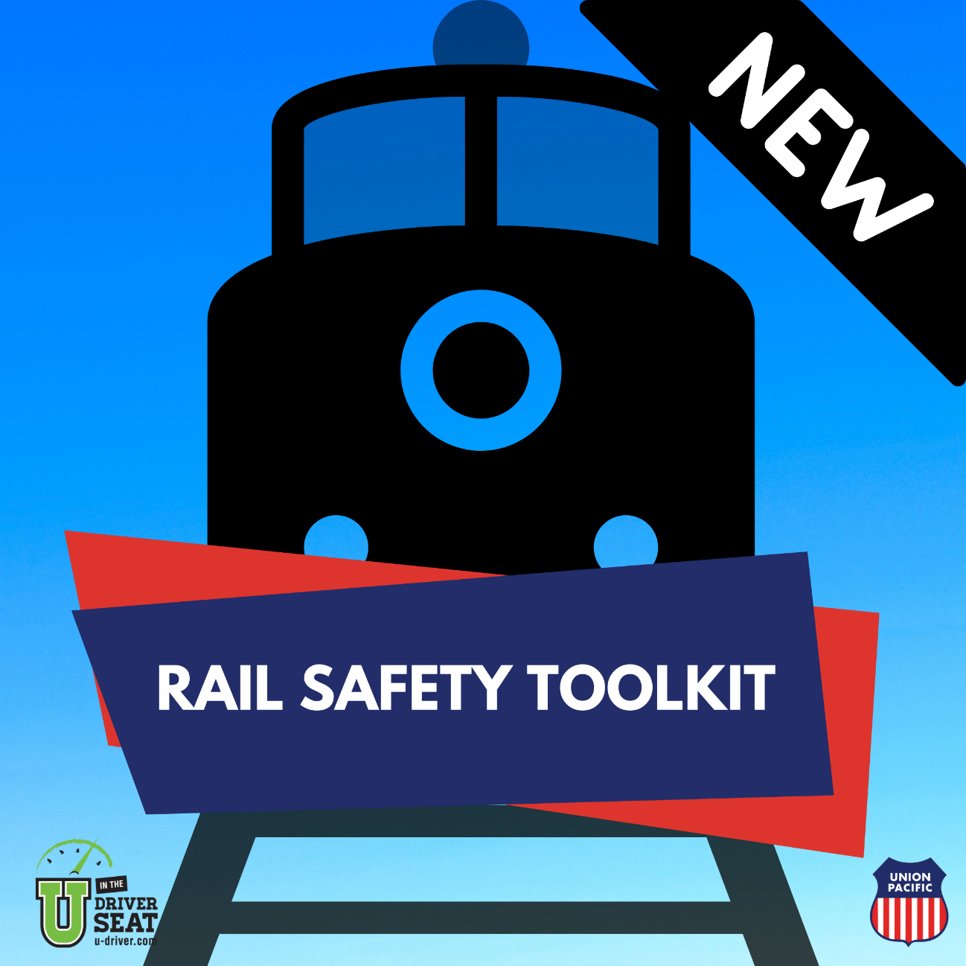
Quick Guide & Sample Messaging

U in the Driver Seat provides the science, resources and support to effectively engage and educate your peers on a variety of traffic safety topics. This social media toolkit is to assist you in talking to your peers about railroad crossing safety, train and track awareness, and laws pertaining to track trespassing.
Our downloadable graphics are square sized for use on various social media channels to display as an album on Instagram or Facebook. We encourage you to make the post your own, but here are some ways to really make it great!
- Tag @UDriverSeat on social media to receive All-Star points
- Add your organization logo to the beginning and ending graphic
- Share the posts to your Instagram or Facebook story
- Invite your Regional Rep to do a Instagram Live interview on the topic
- Host an Ask Me Anything Instagram Story after posting the graphics
- Use the graphics to build out a blog post for your website
Sample Social Media Messages:
- It’s Rail Safety Week. Join us in learning about railroad safety this week! #RailSafety
- Trains are not able to stop as quickly as cars! Be patient and stop whenever a train is coming! and #RailSafety
- Heads Up, Listen Up. When railroad crossing lights begin to flash you have 20 seconds or less before a train arrives. #RailSafety #headsuplistenup
- With an 800 to 1 weight ratio, freight trains are to humans as fly swatters are to flies. Don’t race the train. #RailSafety
- You can’t get hit by a train if you’re not on the tracks. Railroad tracks are private property and it’s illegal to walk on them. #RailSafety
- When stopping for a train, stop at least 15 feet from the nearest train track. Trains are 3 ft wider than the track on both sides. #RailSafety
For more information and valuable resources visit:
- Union Pacific Cares: https://www.up.com/aboutup/community/safety/index.htm
- Operation Lifesavers: https://oli.org/
- Federal Railroad Administration: https://railroads.dot.gov/railroad-safety/safety-fact-sheet

