911 Lifeline Law Social Media Toolkit
By U in the Driver Seat
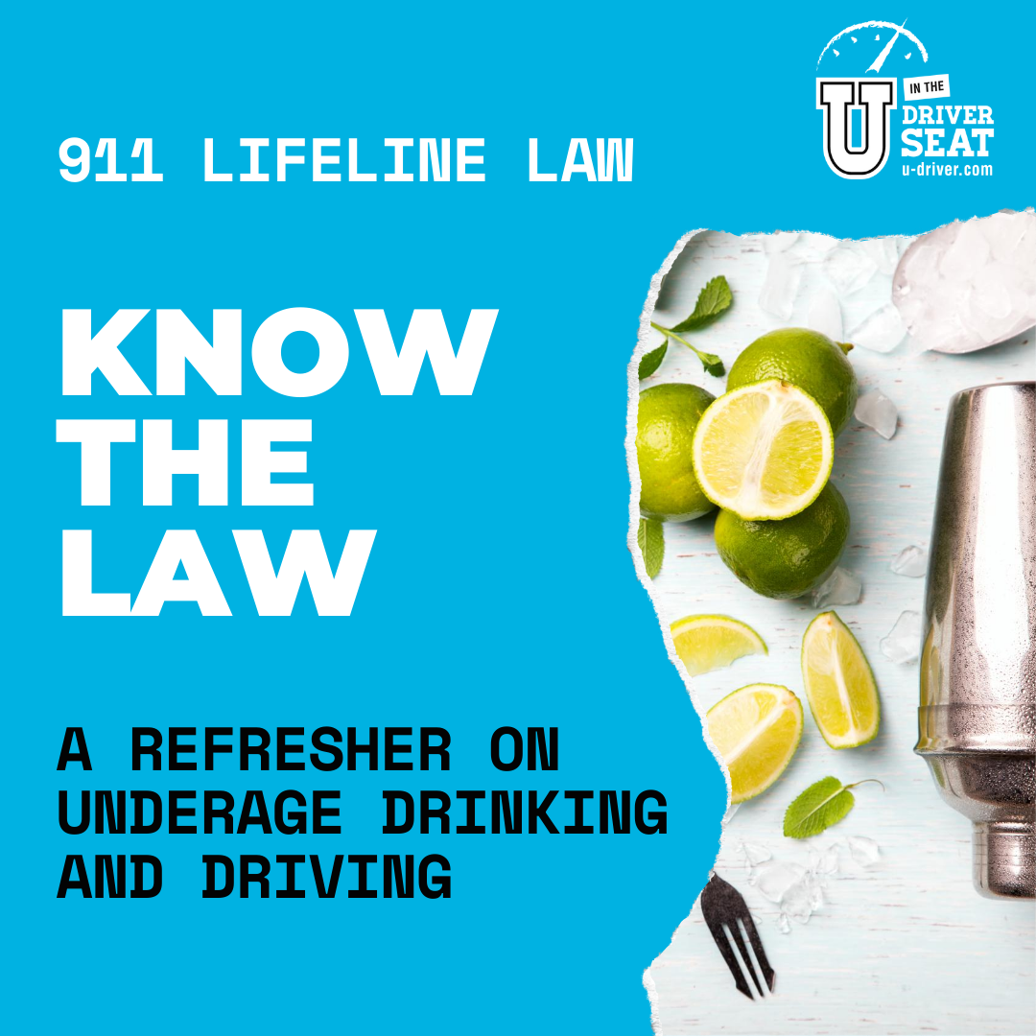
Quick Guide

U in the Driver Seat provides the science, resources and support to effectively engage and educate your peers on a variety of traffic safety topics. This social media toolkit is to assist you in talking to your peers about laws regarding underage drinking and driving, including the 911 Lifeline Laws.
Eight downloadable graphics are square sized for use on various social media channels to display as an album on Instagram or Facebook. We encourage you to make the post your own, but here are some ways to really make it great!
- Tag @UDriverSeat on social media to receive All-Star points
- Add your organization logo to the beginning and ending graphic
- Share the posts to your Instagram or Facebook story
- Invite your UDS Regional Rep to do a Instagram Live interview on the topic
- Host an Ask Me Anything Instagram Story after posting the graphics
- Use the graphics to build out a blog post for your website

For more information and valuable resources visit:
- UDS Underage Drinking Activity Page: https://www.u-driver.com/underage-drinking-toolkit/
- TABC’s 2 Young 2 Drive website: https://www.2young2drink.com/
- UDS Alcohol 101 website: https://www.u-driver.com/driver-risks/impaired-driving/alcohol-101/

