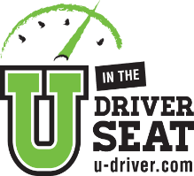  You’re such a Smartie!  Seat belts save over 13,000 lives every year. |  | You’re such a Smartie!  Seat belts save over 13,000 lives every year.
You’re such a Smartie!  Click it or Ticket – you made the best choice! |  | You’re such a Smartie!  Click it or Ticket – you made the best choice!
You’re such a Smartie!  Seat belts save lives. |  | You’re such a Smartie!  Seat belts save lives.
You’re such a Smartie!  Thank you for making sure your passengers are buckled up. |  | You’re such a Smartie!  Thank you for making sure your passengers are buckled up.
You’re such a Smartie!  You know how to wear a seat belt properly to protect you during a crash. |  | You’re such a Smartie!  You know how to wear a seat belt properly to protect you during a crash.
You’re such a Smartie!  And, you look great in that seat belt. |  | You’re such a Smartie!  And, you look great in that seat belt.
You’re such a Smartie!  Buckling up is the most effective thing you can do to protect yourself in a crash. |  | You’re such a Smartie!  Buckling up is the most effective thing you can do to protect yourself in a crash.

